http://www.tradingacademy.com/lessons/20091215/stocks_article.htm

Keeping an Eye on the Big Boys!

By Brandon Wendell, Online Trading Academy Senior Instructor and Trader Mentor
No, this isn’t an article about Tiger. It seems that is all anyone wants to talk about these days. I’m talking about the institutions and large brokerage houses and how their activities, or lack thereof, can influence the markets. As a student of Online Trading Academy, I was taught to watch the actions of the big brokers and to mimic them as they took money from the uneducated, naive investors and traders. As a trader and instructor, I live by this and continue to teach it in the class.
The brokers and institutions are not our enemies. They are not necessarily our allies either. However, they can shed light on some of the direction the markets will take. Imagine walking through a jungle, you can either slash a new path through the thick greenery using a machete, or you can simply stroll through on a path that was created by elephants. Which do you think is easier?
So why do we try to cut through the markets and forge our own paths when the large players are showing us the best way? One of the tools I use to see when the institutions may be buying or selling the stock markets is their money market account balances.
When the big players are not actively long in the markets, they need a place to park their cash. Bonds can be an alternative, but that requires them to liquidate the position before being able to buy equities. A better place to store ready reserves is in the money market. This money is easily deployed when markets offer the opportunity. I understand that this is an assumption about the flow of money, as the money may be going into treasuries instead of equities. However, I will show you how this action can be used to predict changes in the equities’ markets.
The website www.ici.org, the Investment Company Institute, tracks institution versus retail money market levels. They update this list weekly and can offer insights as to the strength or weakness of the trend. When I go to the site, I perform a search for “money market withdraws.” The file I am looking for is Money Market Mutual Funds Assets.

2009-11-05: http://www.ici.org/research/stats/mmf/mm_11_05_09
2009-11-12: http://www.ici.org/research/stats/mmf/mm_11_12_09
2009-11-19: http://www.ici.org/research/stats/mmf/mm_11_19_09
2009-11-25: http://www.ici.org/research/stats/mmf/mm_11_25_09
2009-12-03: http://www.ici.org/research/stats/mmf/mm_12_03_09
2009-12-10: http://www.ici.org/research/stats/mmf/mm_12_10_09
2009-12-17: http://www.ici.org/research/stats/mmf/mm_12_17_09
2009-12-23: http://www.ici.org/research/stats/mmf/mm_12_23_09

Money Market Mutual Fund Assets Historical Data (PDF): http://www.ici.org/pdf/mm_data_2009.pdf

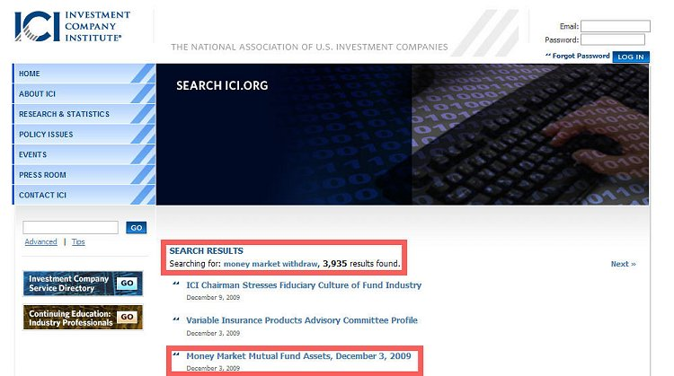
Figure 1

When we go to the selection, you can see the change of funds divided into several sections. Keep in mind that the numbers are in millions of dollars.

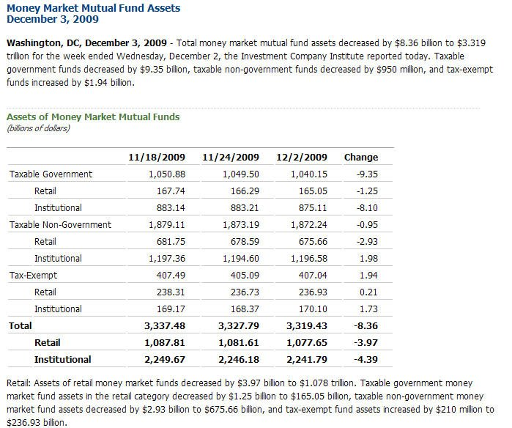
Figure 2

The data I focus on most is the Total Retail versus Total Institution. I am looking for times where they are at odds with each other. When we see institutions putting money into safe money markets while the retail public is withdrawing, it is a warning that the bullish trend is nearing the end. If the retail is depositing money into money markets with institutions withdrawing, it may be a market bottom.
An example is the historic data, found under the same search under Money Market Mutual Fund Assets Historical Data. Looking at the data from March bottom, we see that in the weeks leading up to it, both retail and institutions were putting money in money markets, presumably by withdrawing it from the stock market. On the week of the bottom, March 11th, the institutions withdrew $10 Billion from money markets while retail levels rose by $10.6 Billion!

Money Market Mutual Fund Assets Historical Data (PDF): http://www.ici.org/pdf/mm_data_2009.pdf
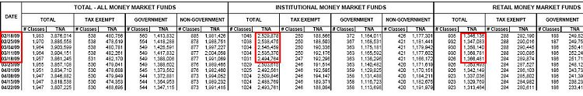
Figure 3

For more evidence on the clues the institutions give us, look to the start of the recent market resistance. The S&P 500 has been stuck below 1113 for several weeks. This should not be a surprise to any trader who noticed the large addition of funds to the institutional money markets even as retail traders continued to buy stock.

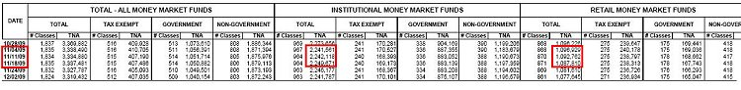
Figure 4
Remember, the elephant leaves tracks. Do not try to fight your way through the market jungle alone. Walk the easier path and just be careful to watch your step!
Have a great day.

- Brandon Wendell bwendell@tradingacademy.com

